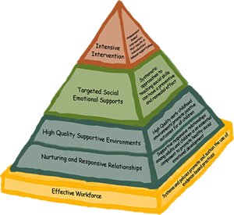 Center on the Social Emotional Foundations for Early Learning (CSEFEL)
http://csefel.vanderbilt.edu/resources/strategies.html
- Resources for Teachers/Caregivers – Printable resources including Scripted Stories for Social Situations; Teaching Social Skills (Feelings Charts, Emotion Faces, Tucker Turtle, Problem Solving, Solutions Kit)

 Technical Assistance Center on Social Emotional Intervention (TACSEI)
http://challengingbehavior.fmhi.usf.edu/do/resources/backpack.html
- Backpack Connections Series – Provide information to help parents stay informed about what their child is learning at school and specific ideas on how to use the strategy or skill at home.

 Center for Early Childhood Mental Health Consultation
http://www.ecmhc.org/relaxation.html

- Taking Care of Ourselves – Resources to reduce stress.

 Head Start Center for Inclusion
http://depts.washington.edu/hscenter/teacher-tools#visual
- Classroom visuals and supports – Resources include Steps to Initiating Play, Emotional Regulation, Dragon Brain, Problem Solving and General Behavior.

