The Office of Vocational Rehabilitation (OVR)

Mission
OVR serves people who have disabilities that present a barrier to employment. Services are provided to individuals to prepare for, enter into, engage in, or retain employment. We work with individuals with: physical, sensory, cognitive, emotional, and health related disabilities. Potentially Eligible students have an IEP, 504 plan, or perceived disability (mental health, drug/alcohol).
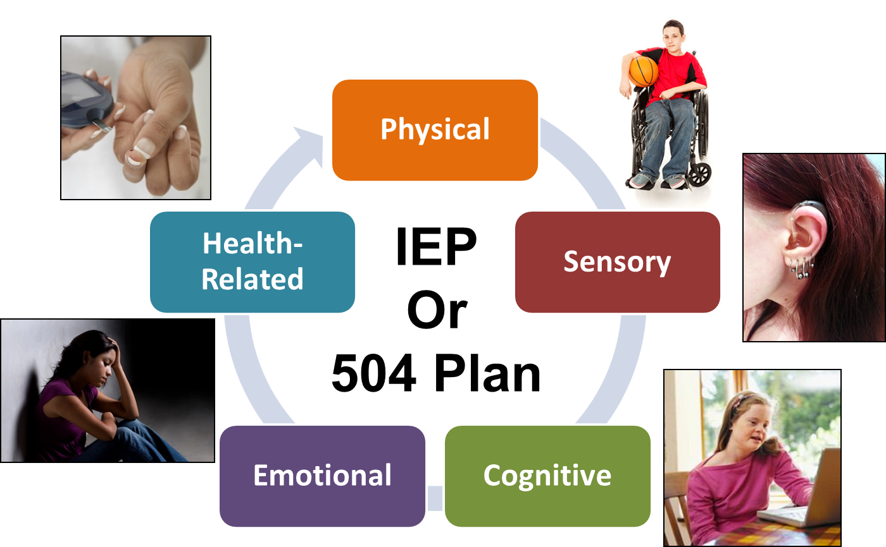

- Physical disability: People with this type of disability may have difficulties with movement or mobility. They may use assisted devices such as wheelchairs or walkers. (Cerebral Palsy, Paralysis, Amputation)
- Sensory disability: People with this type of disability may have difficulty hearing or seeing, or both. Individuals with visual impairments may use Braille, canes, or large print to assist them. People who are hard of hearing or deaf may use hearing aids or cochlear implants. (Hard of Hearing, Deaf, Blind)
- Cognitive disability: People with this type of disability may have difficulty learning, communicating, and remembering information. They may also have trouble with problem-solving, paying attention, or understanding reading, math, or visual information. They may use daily planners, more time on tests, or quiet areas to study. (Learning Disabilities, ADHD, Autism, Intellectual/Developmental Disabilities)
- Psychiatric and Emotional disability: People with these types of disabilities may have difficulty with emotions and behaviors. Often these individuals are diagnosed with Depressive Disorder, Drug Addiction, Anxiety Disorder, Psychotic Disorder, and/or Mood Disorder. People with this type of disability may use medications, coping skills, or counseling.
- Health-related disability: People with this type of disability might have a physical condition that affects their overall health. They may have limited strength, vitality, or alertness due to chronic or acute health problems such as a heart condition, rheumatic fever, asthma, hemophilia, and leukemia.

To Apply to OVR:

- Contact your High School’s - Transition Coordinator for an OVR application (paper).
- We will need: a completed OVR application, copy of school/photo ID, copy of student’s IEP and Reevaluation Report

Pre-Employment Transition Services for High School Students:

- Group Services – OVR will fund for an Agency to provide these trainings in your High School:
- Independent Living Skills Training
  - Skills needed to live independently - May include Budgeting, Home management skills
- Self-Advocacy Training
  - May include disability awareness, how to advocate during an IEP meeting, understanding the transition process, advocating for yourself in post-secondary education, employment, or with social service agencies.
- Workplace Readiness Training
  - May include soft skills training, interview skills, job readiness, job seeking skills, HR practices
- Individual Services
- Job Shadowing – 1 to 5-day job shadowing experience, in an occupation of interest, in the community. Students will shadow employees and obtain an overview of knowledge, tasks, and abilities needed to work in that job. Includes 25 hours with provider staff to observe careers of interest, unpaid
- Work Based Learning Experience – Students will be provided with options for work experiences that teach skills needed to obtain competitive integrated employment or transition to post-secondary training. Includes 20 hours for a provider agency to develop the work experience. 90 hours of paid part time temporary work with the support of provider agency staff.
- Dual Enrollment Credits – OVR Financial support for college-level course while enrolled in High School. OVR will fund tuition, the purchase of books, and supplies needed to participate in course. Student may attend course at college, at secondary entity, or online. Remedial Courses are allowable if needed to progress to college level. 1 Course Per Semester, During the last year of High School

Other Services:
  - Testing/Diagnostic services – OVR will fund testing for the purpose of determining a disability, the extent of a disability, or assistive technology needed. Testing may also assess an individual’s ability to work. Includes: psychological, neuropsychological, physiatric (physical assessment), community-based-work-assessments, AT (assistive technology)
  - Vocational Counseling and Guidance – OVR Vocational Rehabilitation Counselors provide counseling on vocational options, post-secondary options, connect individuals to other services/supports
  - Job Coaching – Individualized support to prepare a resume, conduct a job search, practice for a job interview, learn job tasks, request accommodations at work
  - Equipment/Assistive Technology – Assessments for and training on how to use assistive equipment to aid with employment (hearing aids, home and vehicle modifications, assistive devices for learning)
  - Training – OVR financial support for accredited training programs – College, Tech/Trade School, Certificate Programs, Comprehensive Training Programs (college programs for individuals with intellectual disabilities), Driver Evaluation/Training – assessment and training for safe vehicle operation
  - Occupational Tools/Equipment/Uniforms/License – OVR may fund for tools, equipment, uniforms, or a license needed to perform job duties.
  - Job Placement Assistance – OVR hosts workshops for: Job Leads, Resume Writing and Job Interview workshops
  - Hiram G. Andrews Center – Training Center in Johnstown, PA - www.dli.pa.gov/hgac - Offers Associates degree and Certificate programs. Student will visit for a Vocational Evaluation (2-3 weeks) to determine successful placement in chosen program before attending.

