Appendix C
Functional Assessment
Secondary Team Forms

- Functional Assessment Interview Form: FACTS A & B
- Routines Analysis

Functional Assessment Checklist for Teachers and Staff
(FACTS-Part A – Problem Identification)

Student/Grade:____________________ Date: __________________

Interviewer: _______________________ Respondent(s): _________

Student Profile: Please identify at least three strengths or contributions the student brings to school.

Problem Behavior(s): Identify & Describe Problem Behaviors Specifically:

___Tardy  ___Unresponsive  ___Withdrawn | ___Inappropriate Language  ___Fight/Physical Aggressive  ___Verbal Harassment |  |  | ___Disruptive  ___Insubordination  ___Work not done |  | ___Theft  ___Vandalism  ___Other_________________
Describe the problem behavior(s) specifically - - What does it look like/sound like :

Identify Routines: Where, When and With Whom Problem Behaviors are Most Likely:
Schedule (Times) |  | Activity | With Whom does Problem Occur |  | Likelihood of  Problem Behavior |  | Specific Problem Behavior
Low High
1 2 3 4 5 6
 |  |  |  |  | 1 2 3 4 5 6
 |  |  |  |  | 1 2 3 4 5 6
 |  |  |  |  | 1 2 3 4 5 6
 |  |  |  |  | 1 2 3 4 5 6
 |  |  |  |  | 1 2 3 4 5 6
 |  |  |  |  | 1 2 3 4 5 6
 |  |  |  |  | 1 2 3 4 5 6

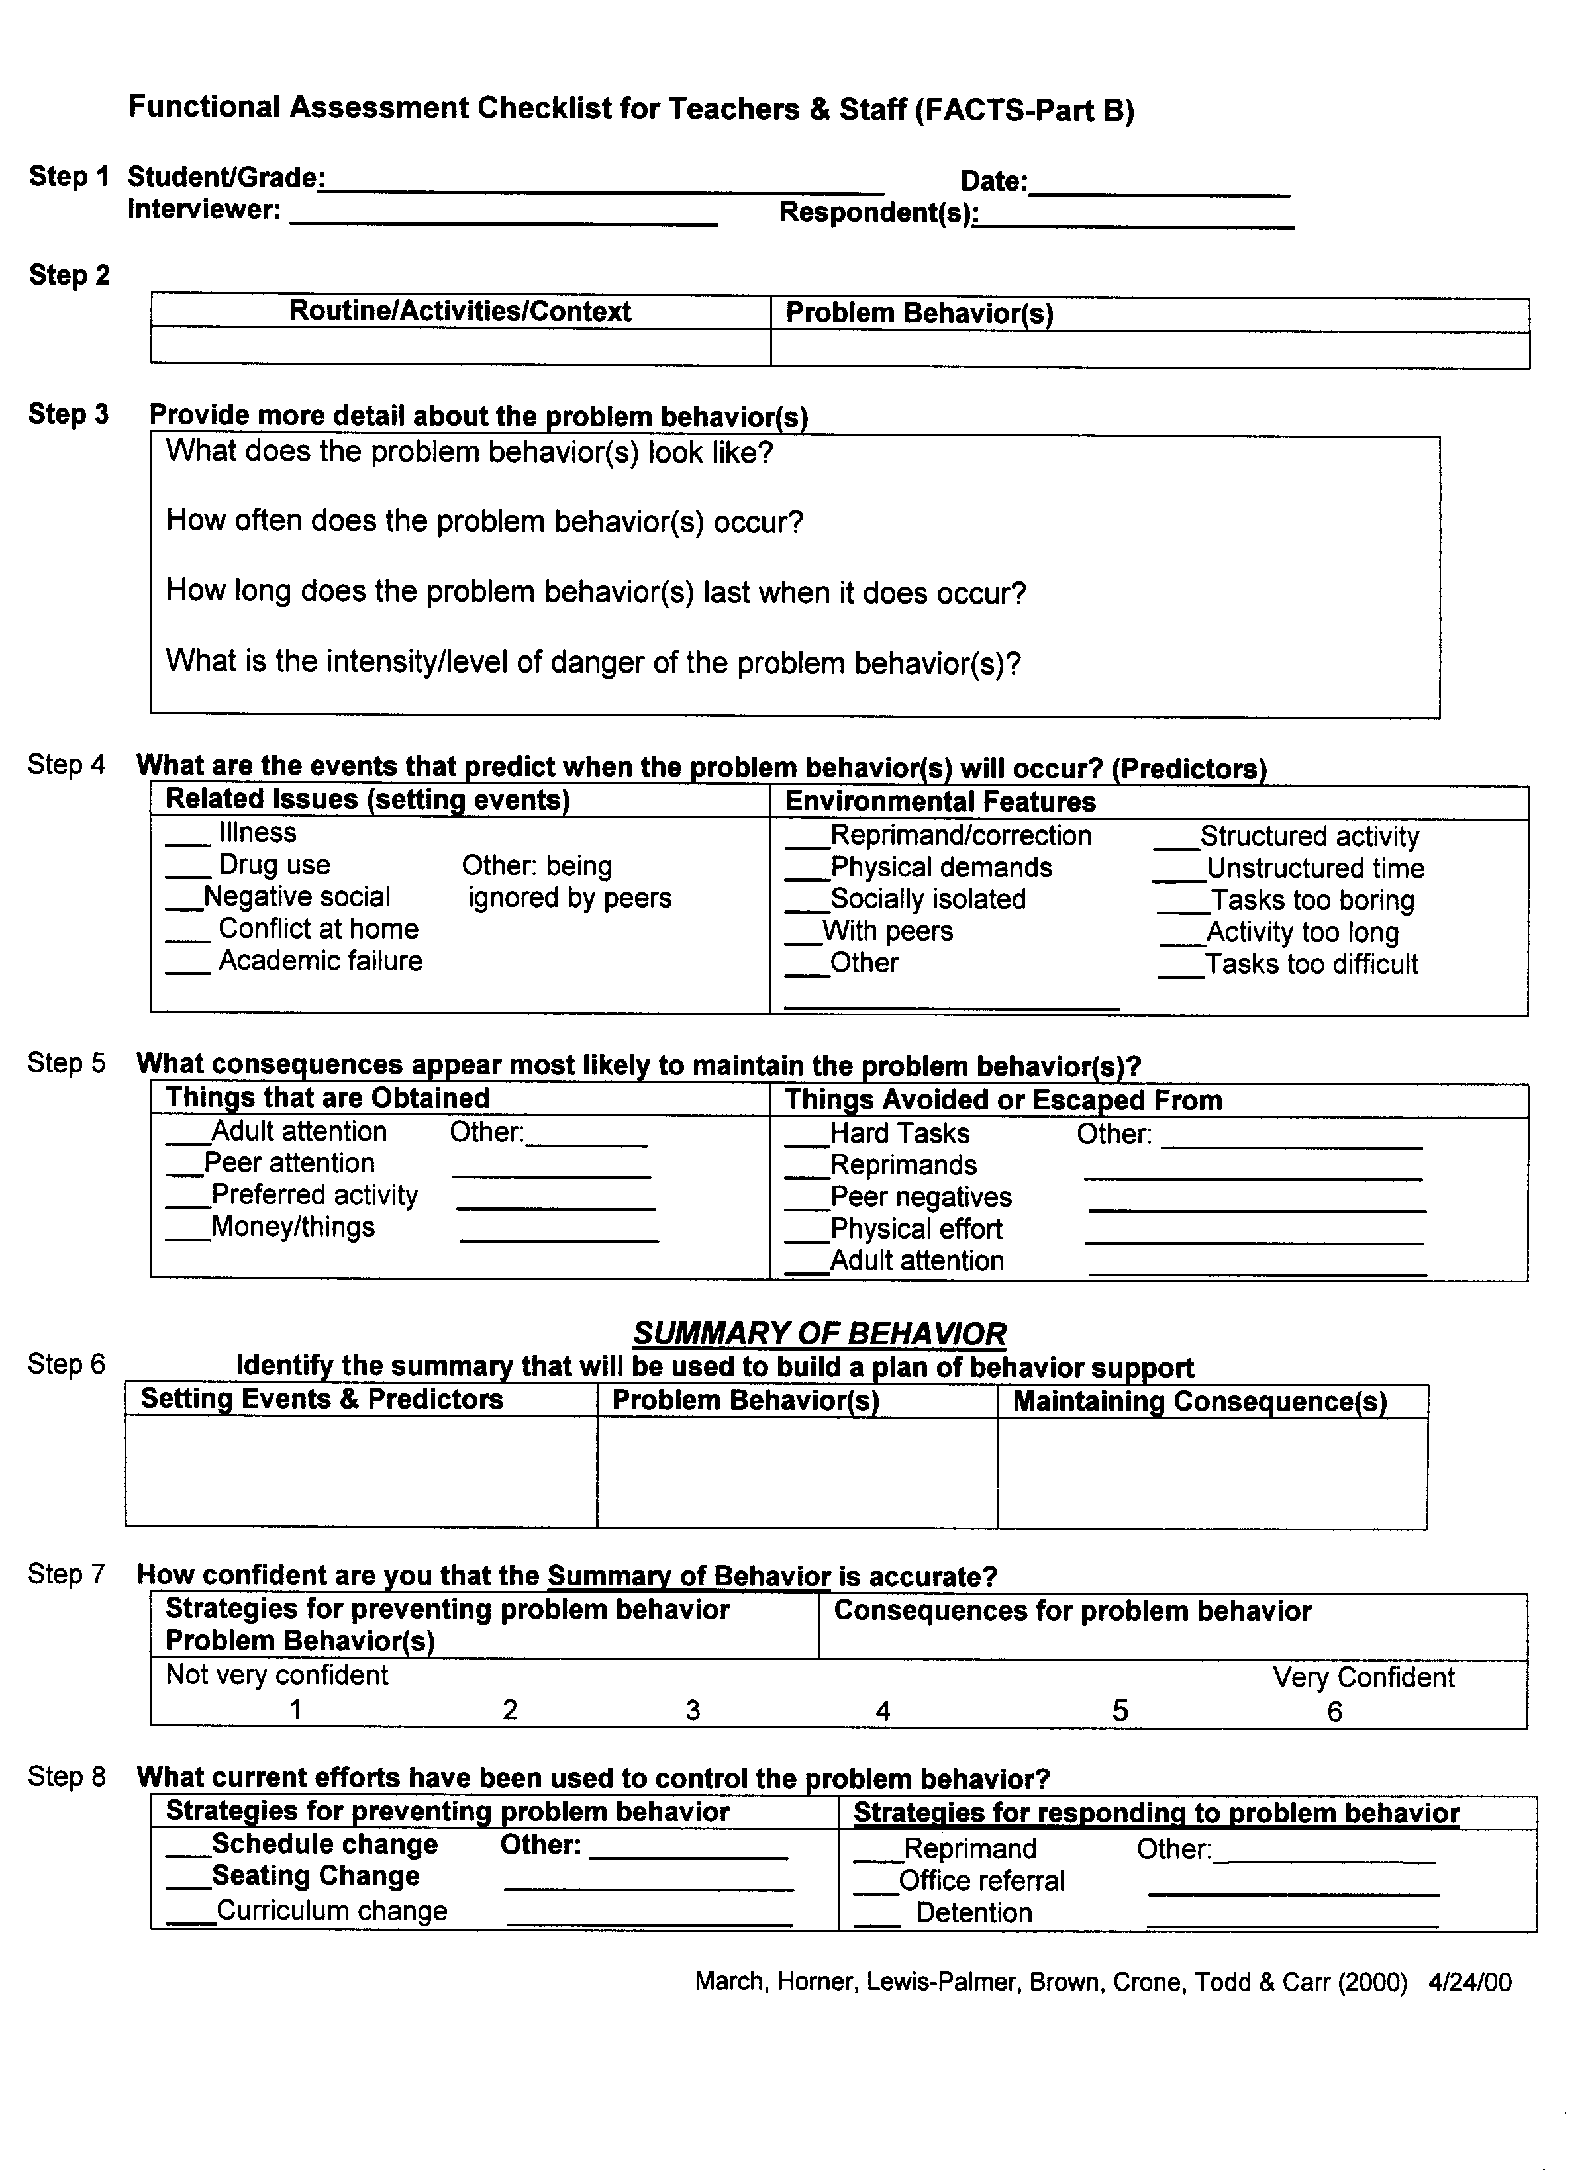

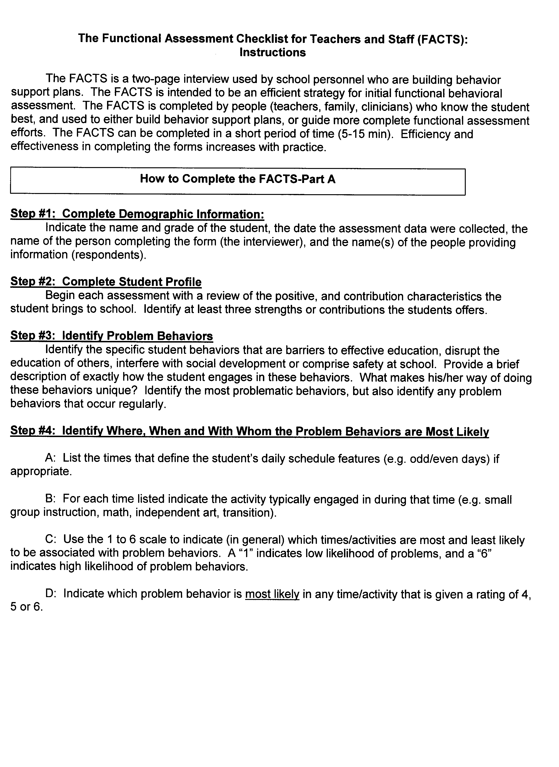

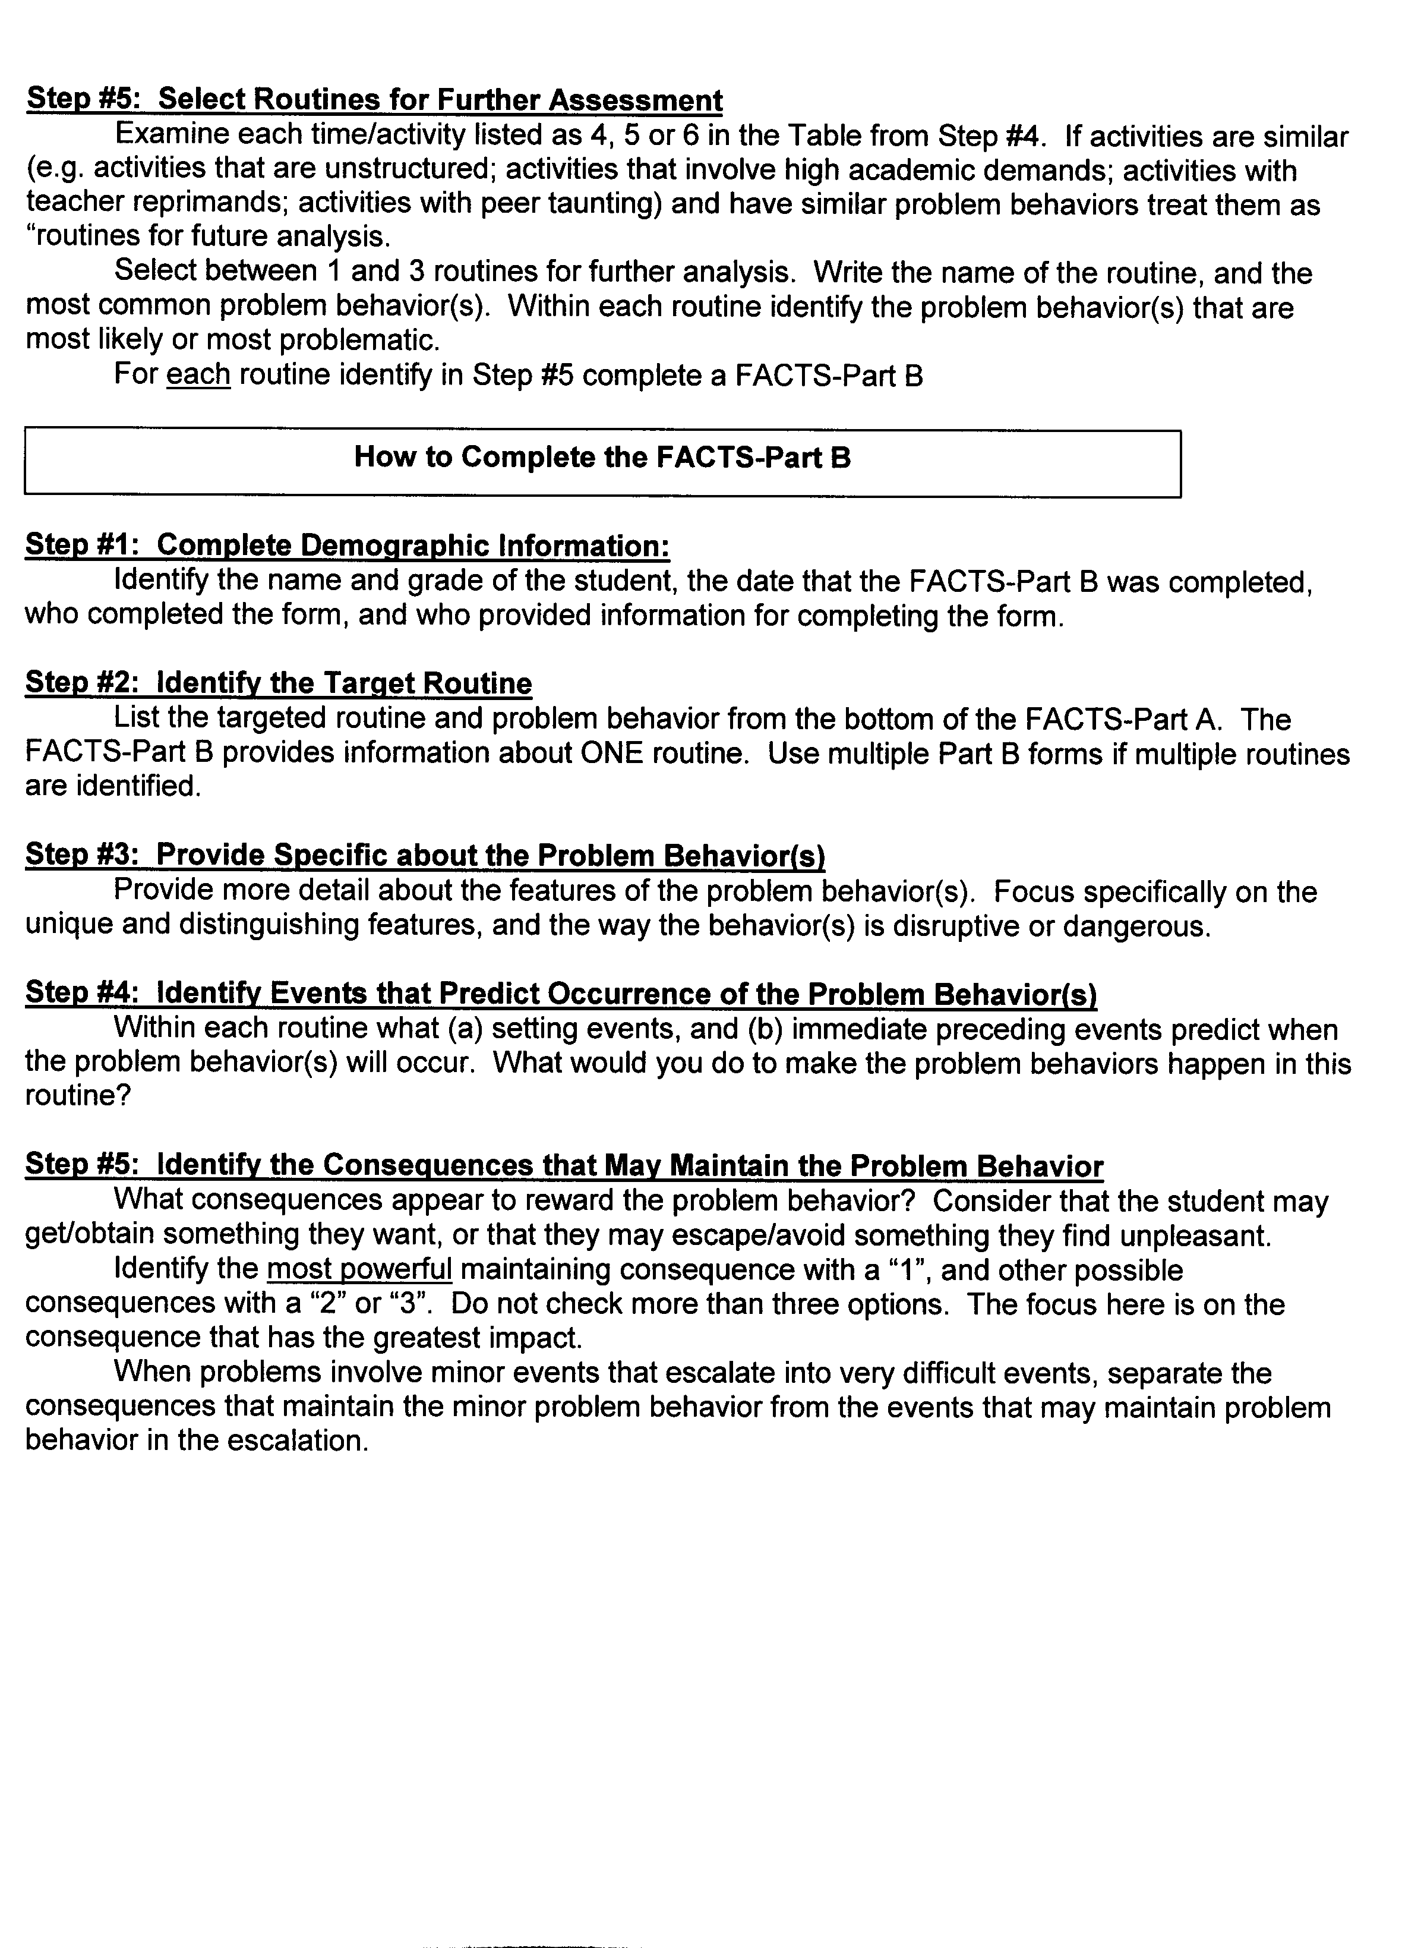

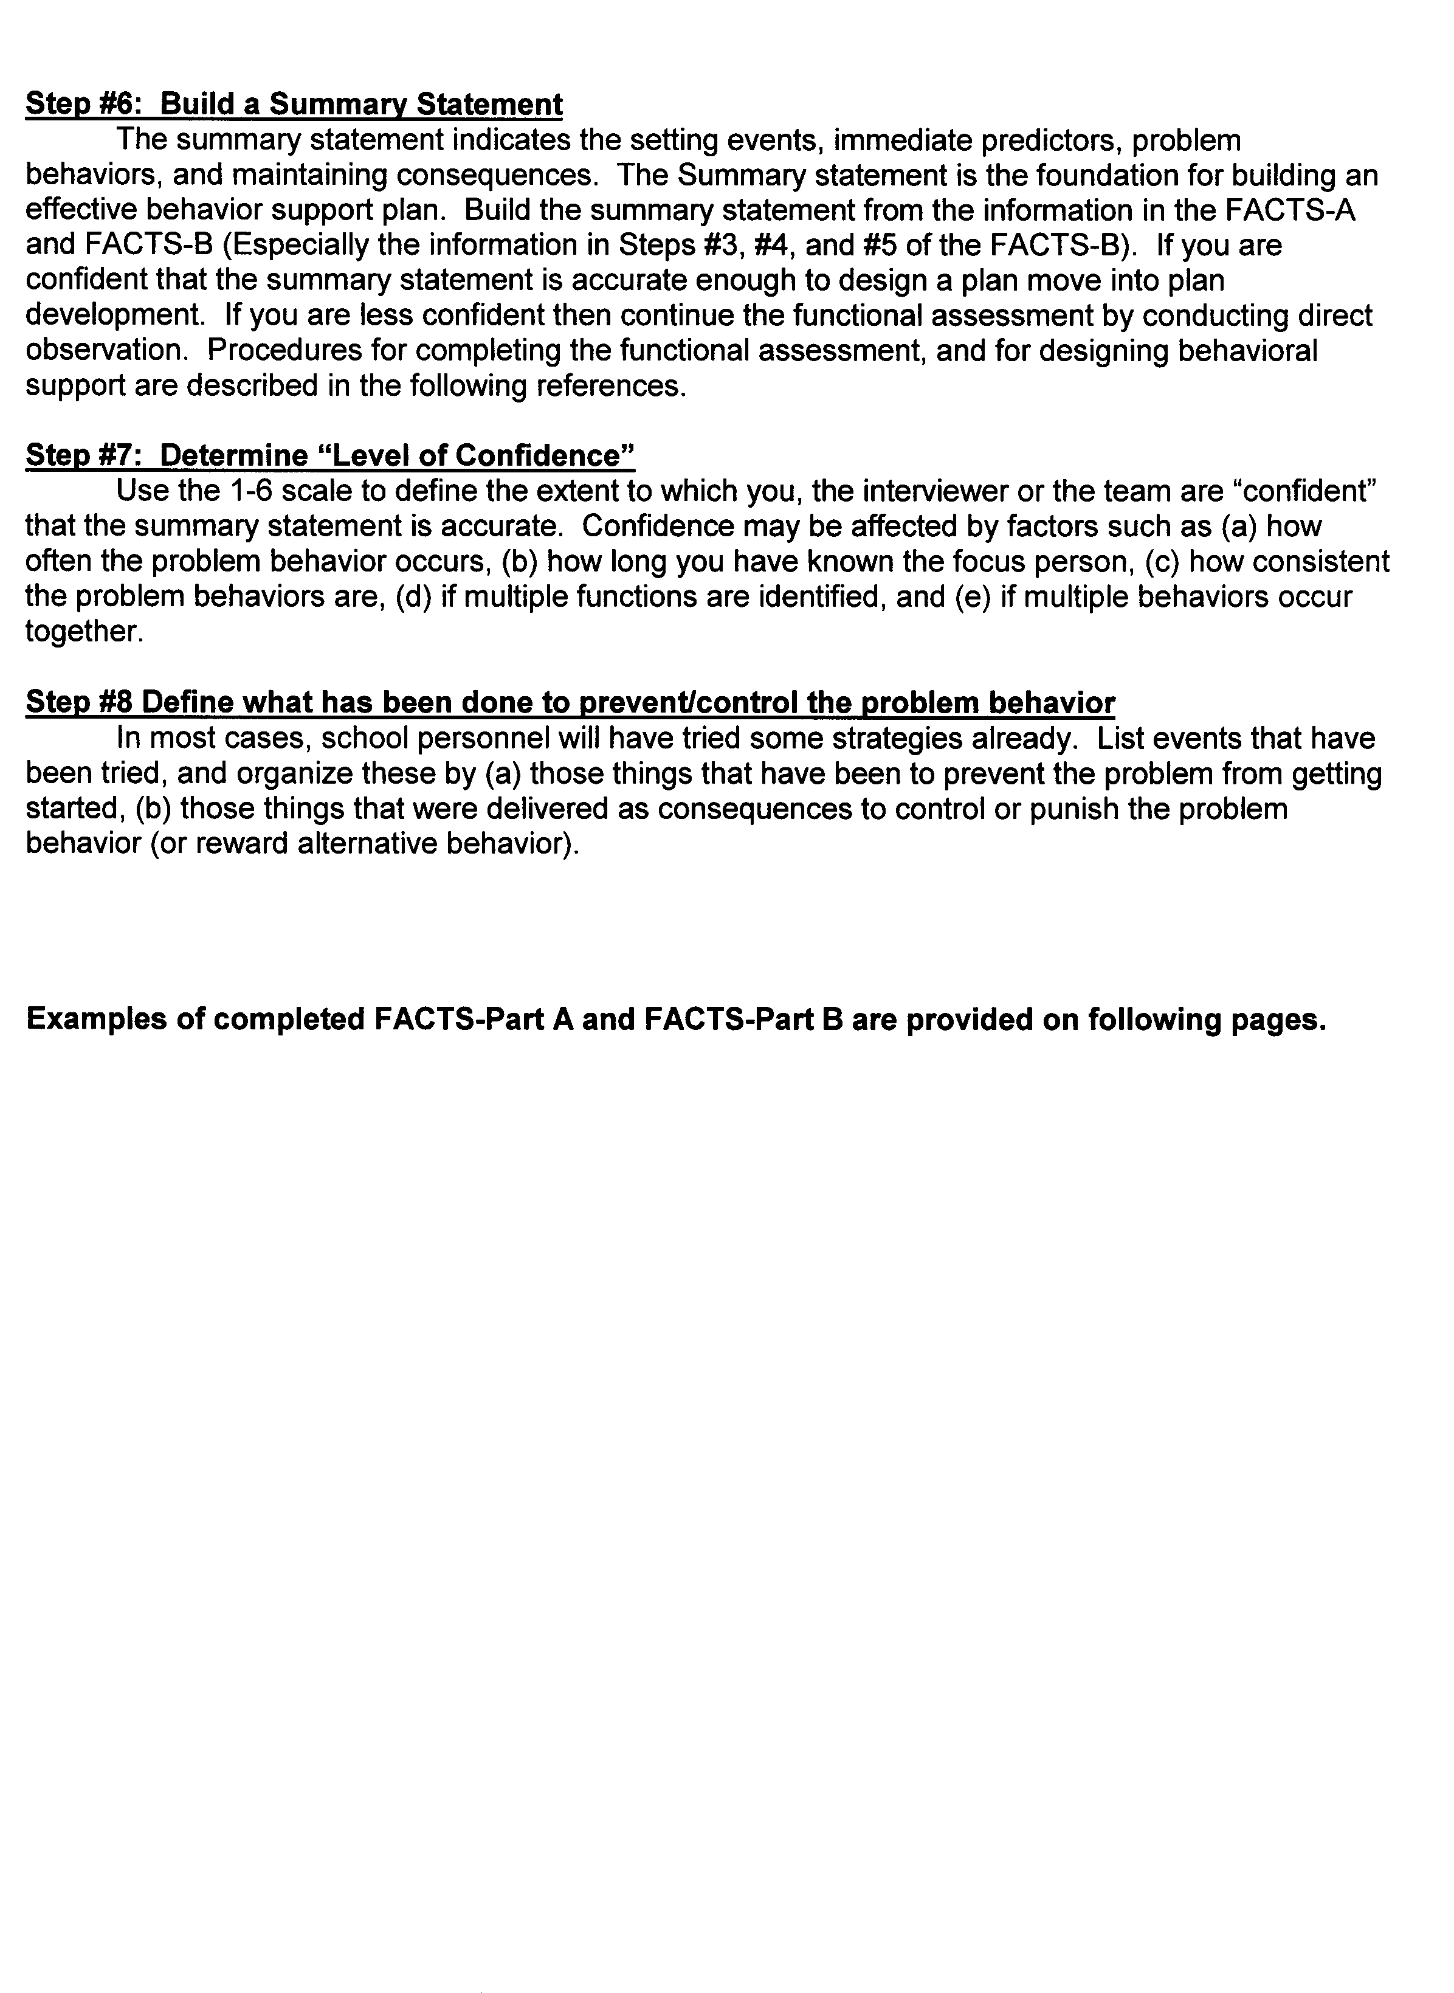

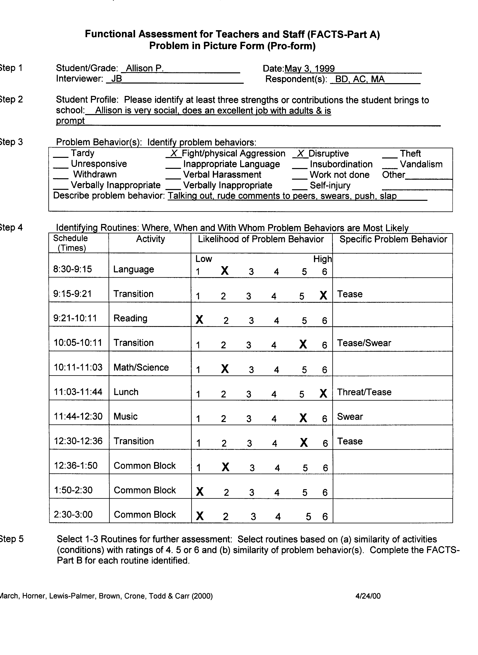

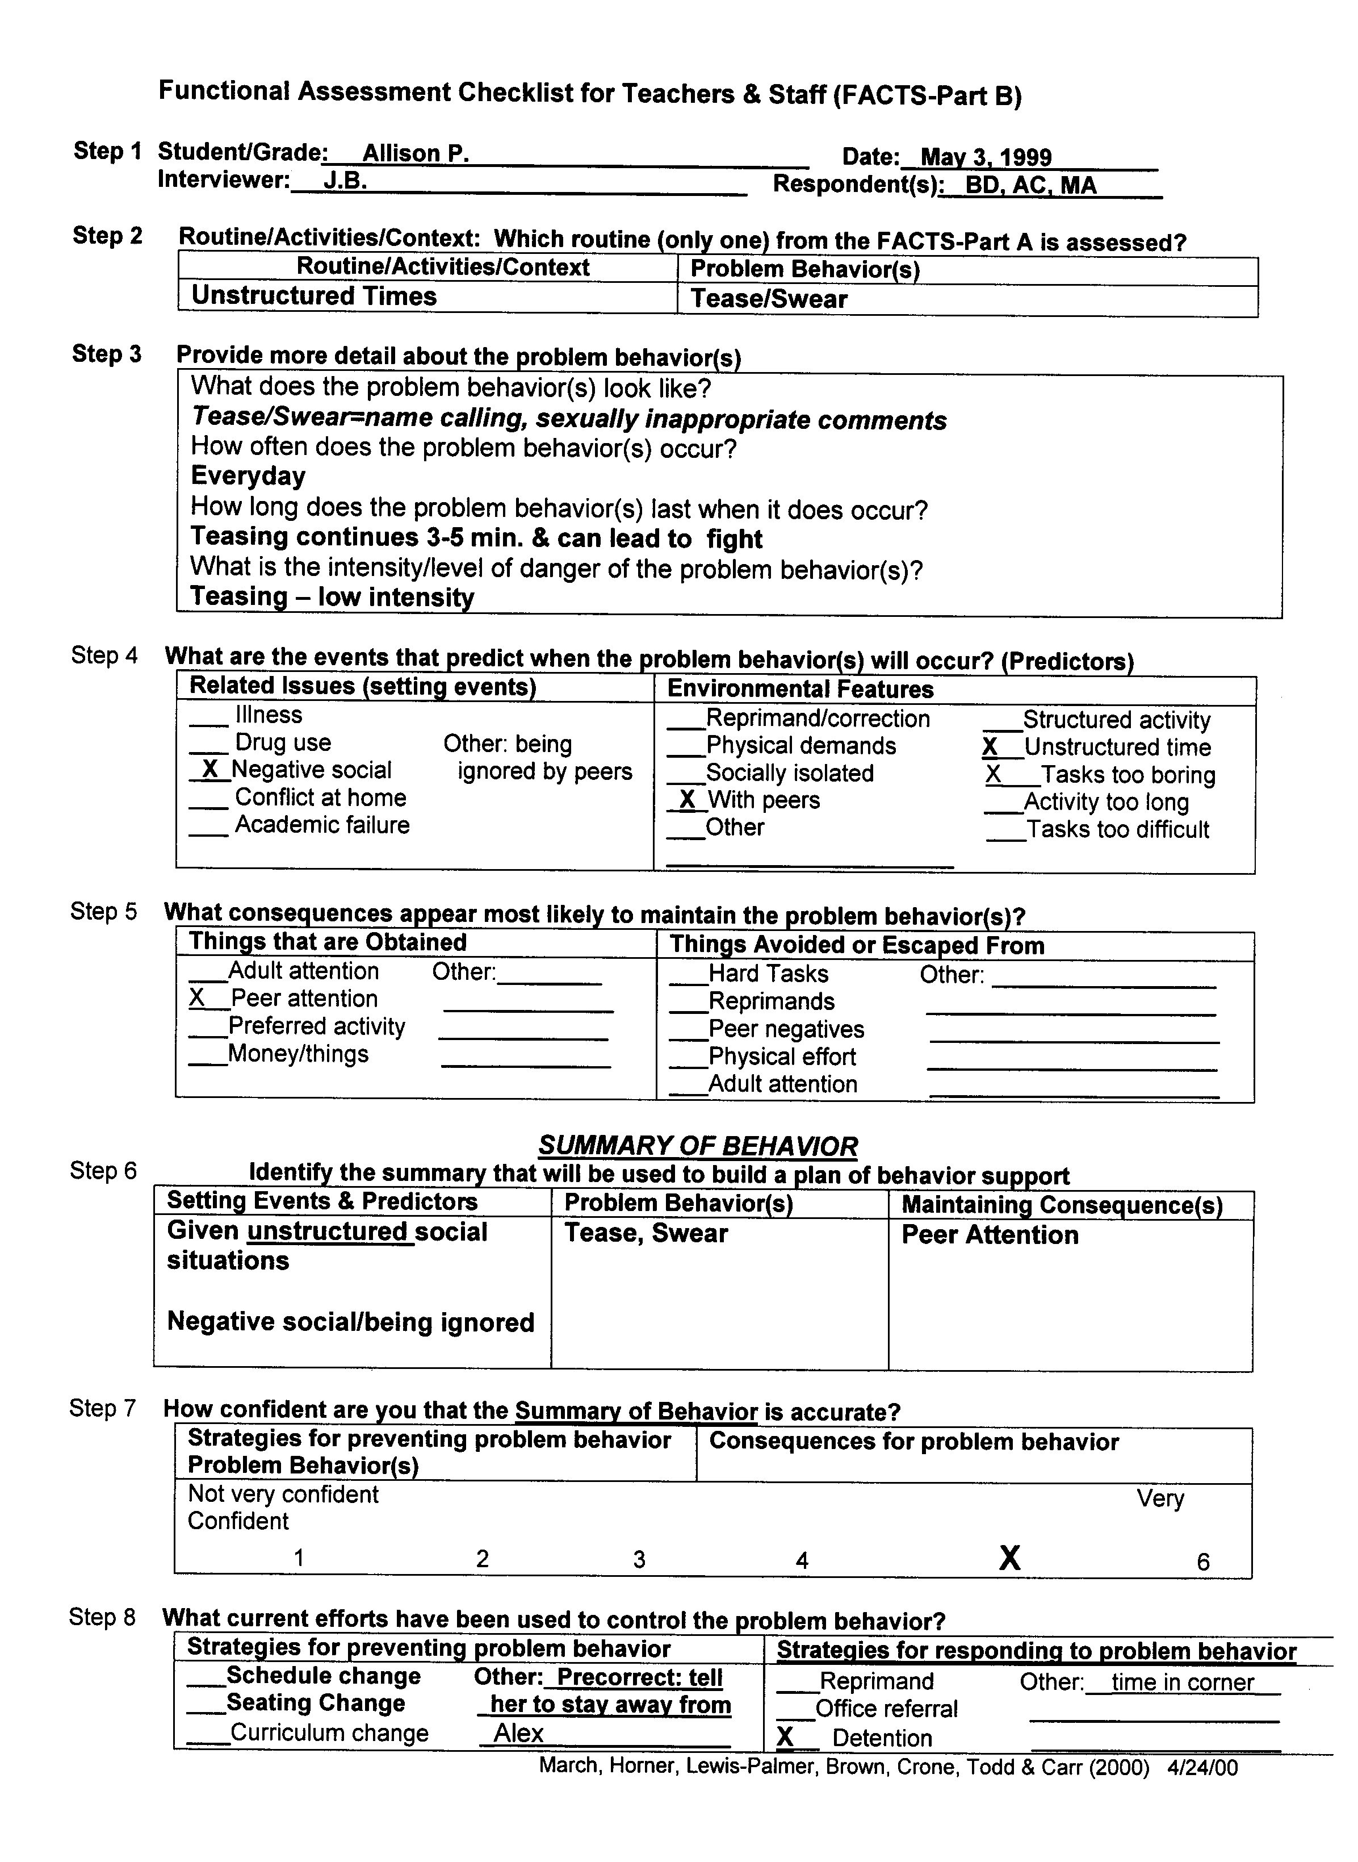
Functional Assessment Checklist for Teachers and Staff (FACTS-Part A)
Problem in Picture Form (Pro-form)

Student/Grade: Ronald/ 7th Grade Date:

Interviewer: Mrs. Snow Respondent(s):

Student Profile: Please identify at least three strengths or contributions the student brings to school.

Problem Behavior(s): Identify problem behaviors
___Tardy  ___Unresponsive  ___Withdrawn |  | ___Inappropriate Language  ___Fight/Physical Aggressive  ___Verbal Harassment |  | ___Disruptive  ___Insubordination  ___Work not done |  | ___Theft  ___Vandalism  ___Other_________________
Describe problem behavior :Gets angry at peers’ comments of, if he can’t do the class work. Strikes out at whomever made him angry. Gets in big fights-verbally and physically.
Identify Routines: Where, When and With Whom Problem Behaviors are Most Likely.
Schedule (Times) | Activity |  | With Whom does Problem Occur |  | Likelihood of  Problem Behavior |  | Specific Problem Behavior
8:20-9:15 | Science |  | Peers |  | Low High  1 2 3 X 5 6 |  | Fighting
9:20-10:15 | Math |  | Teacher |  | 1 2 3 4 5 X |  | Yelling, work refusal
10:20-11:15 | Reading |  | Teacher |  | 1 2 3 4 5 X |  | Yelling, work refusal
11:15-12:15 | Spanish |  | Teacher |  | 1 2 3 4 X 6 |  | Yelling, work refusal
12:20-1:00 | Lunch |  |  |  | X 2 3 4 5 6
1:05-2:00 | Social Studies |  | Peers |  | 1 2 3 X 5 6 |  | Fighting
2:05-3:00 | Physical Education |  |  |  | X 2 3 4 5 6
 |  |  |  |  | 1 2 3 4 5 6
 |  |  |  |  | 1 2 3 4 5 6
 |  |  |  |  | 1 2 3 4 5 6
 |  |  |  |  | 1 2 3 4 5 6

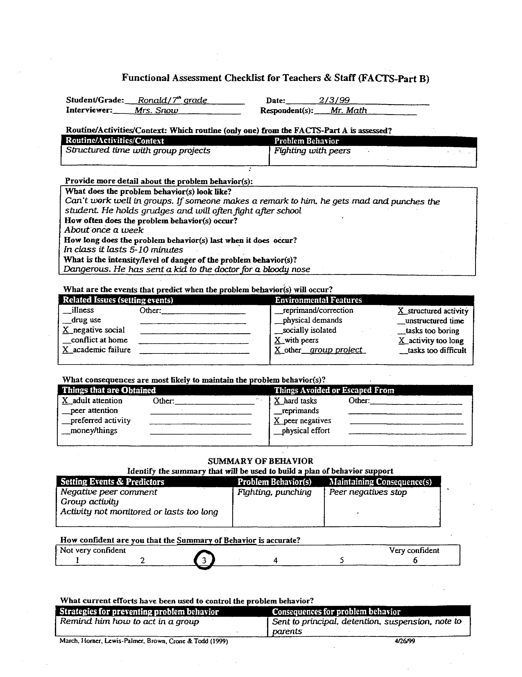
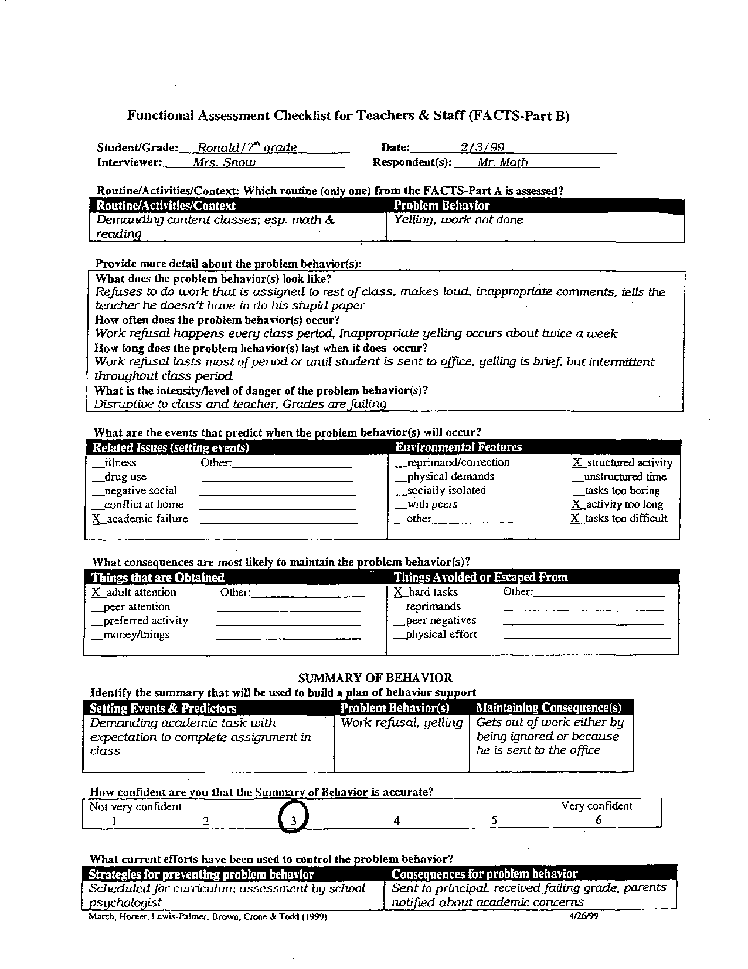
PROBLEM BEHAVIOR QUESTIONAIRE
Respondent Information

Student DOB Grade Sex: M F IEP: Y N

Teacher School

Telephone Date

STUDENT BEHAVIOR: Please briefly describe the problem behavior(s)

DIRECTIONS: Keeping in mind a typical episode of the problem behavior, circle the frequency at which each of the following statements are true.

PERCENT OF THE TIME

Never 10% 25% 50% 75% 90% Always
1. Does the problem behavior occur and persist when you
make a request to perform a task? 0 1 2 3 4 5 6

2. When the problem behavior occurs, do you redirect the
student to get back to task or follow rules? 0 1 2 3 4 5 6

3. During a conflict with peers, if the student engages in the
problem behavior, do peers leave the student alone? 0 1 2 3 4 5 6

4. When the problem behavior occurs, do peers verbally
respond or laugh at the student? 0 1 2 3 4 5 6

5. Is the problem behavior more likely to occur following a
conflict outside the classroom? (e.g., bus write up) 0 1 2 3 4 5 6

6. Does the problem behavior occur to get your attention
when you are working with other students? 0 1 2 3 4 5 6

7. Does the problem behavior occur in the presence of
specific peers? 0 1 2 3 4 5 6

8. Is the problem behavior more likely to continue to occur
throughout the day following an earlier episode? 0 1 2 3 4 5 6

9. Does the problem behavior occur during specific
academic activities? 0 1 2 3 4 5 6

10. Does the problem behavior stop when peers stop
interacting with the student? 0 1 2 3 4 5 6

11. Does the behavior stop when peers are attending to
other students? 0 1 2 3 4 5 6

12. If the student engages in the problem behavior, do you
provide one-on-one instruction to get student back on–task? 0 1 2 3 4 5 6

13. Will the student stop doing the problem behavior if you
stop making requests or end an academic activity? 0 1 2 3 4 5 6

14. If the student engages in the problem behavior, do
peers stop interacting with the student? 0 1 2 3 4 5 6

- Is the problem behavior more likely to occur following 0 1 2 3 4 5 6
Unscheduled events or disruptions in classroom routines?

Source: Lewis, T.J., Scott, T.M., and Sugai, G. (1994). The problem behavior questionnaire: A teacher-based instrument to develop functional hypotheses of problem behavior in general education settings. Diagnostique, 19, 103-115. Reprinted with permission.

PROBLEM BEHAVIOR QUESTIONAIRE PROFILE

Student Grade

School Date

DIRECTIONS: Circle the score given for each question from the scale below the corresponding question number (in bold.)

PEERS |  | ADULTS |  | SETTING EVENTS
Escape | Attention | Escape | Attention
3 10 14 | 4 7 11 | 1 9 13 | 2 6 12 | 5 8 15
6 6 6  5 5 5  4 4 4  3 3 3  2 2 2  1 1 1  0 0 0 | 6 6 6  5 5 5  4 4 4  3 3 3  2 2 2  1 1 1  0 0 0 | 6 6 6  5 5 5  4 4 4  3 3 3  2 2 2  1 1 1  0 0 0 | 6 6 6  5 5 5  4 4 4  3 3 3  2 2 2  1 1 1  0 0 0 | 6 6 6  5 5 5  4 4 4  3 3 3  2 2 2  1 1 1  0 0 0

ANALYSIS OF POSSIBLE FUNCTION(S) OF STUDENT BEHAVIOR

APPENDIX E: PROBLEM BEHAVIOR QUESTIONAIRE
Respondent Information

Student Trish DOB 2/24/19-- Grade 4th Sex: M IEP:Y

Teacher Mr Church School Tucker Creek Elementary

Telephone Date 9/30/19--
N
F

STUDENT BEHAVIOR: Please briefly describe the problem behavior(s)
Disruptive and aggressive behavior on the playground.
DIRECTIONS: Keeping in mind a typical episode of the problem behavior, circle the frequency at which each of the following statements are true.
PERCENT OF THE TIME

Never 10% 25% 50% 75% 90% Always
1. Does the problem behavior occur and persist when you
1
make a request to perform a task? 0 2 3 4 5 6

2. When the problem behavior occurs, do you redirect the
4
student to get back to task or follow rules? 0 1 2 3 5 6

- During a conflict with peers, if the student engages in the
1
problem behavior, do peers leave the student alone? 0 2 3 4 5 6

- When the problem behavior occurs, do peers verbally
6
respond or laugh at the student? 0 1 2 3 4 5

- Is the problem behavior more likely to occur following a
2
conflict outside the classroom? (e.g., bus write up) 0 1 3 4 5 6

- Does the problem behavior occur to get your attention
4
when you are working with other students? 0 1 2 3 5 6

- Does the problem behavior occur in the presence of
5
specific peers? 0 1 2 3 4 6

- Is the problem behavior more likely to continue to occur
1
throughout the day following an earlier episode? 0 2 3 4 5 6
0
- Does the problem behavior occur during specific
academic activities? 1 2 3 4 5 6

- Does the problem behavior stop when peers stop
2
interacting with the student? 0 1 3 4 5 6

- Does the behavior stop when peers are attending to
5
other students? 0 1 2 3 4 6

- If the student engages in the problem behavior, do you
5
provide one-on-one instruction to get student back on–task? 0 1 2 3 4 6

- Will the student stop doing the problem behavior if you
0
stop making requests or end an academic activity? 1 2 3 4 5 6

- If the student engages in the problem behavior, do
1
peers stop interacting with the student? 0 2 3 4 5 6
- Is the problem behavior more likely to occur following
4
unscheduled events or disruptions in classroom routines? 0 1 2 3 5 6
PROBLEM BEHAVIOR QUESTIONAIRE PROFILE

Student Trish Grade 4th

School Tucker Creek Elementary Date 9/30/19--

DIRECTIONS: Circle the score given for each question from the scale below the corresponding question number (in bold.)

PEERS |  | ADULTS |  | SETTING EVENTS
Escape | Attention | Escape | Attention
3 10 14 | 4 7 11 | 1 9 13 | 2 6 12 | 5 8 15
6 6 6  5 5 5  4 4 4  3 3 3  2 2  1  0 0 0 | 6 6  5  4 4 4  3 3 3  2 2 2  1 1 1  0 0 0 | 6 6 6  5 5 5  4 4 4  3 3 3  2 2 2  1 1  0 | 6 6 6  5 5  4  3 3 3  2 2 2  1 1 1  0 0 0 | 6 6 6  5 5 5  4 4  3 3 3  2 2  1 1  0 0 0
2
1
1
6
5
5
1
0
0
5
4
4
4
2
1

ANALYSIS OF POSSIBLE FUNCTION(S) OF STUDENT BEHAVIOR

Trish appears to get attention from her peers and adults when engaging in inappropriate behavior.

