Indicator 13 IEP Writer Pre and Post Review
Step 1: In the top menu of IEP Writer navigate to “My District” > “District Options”
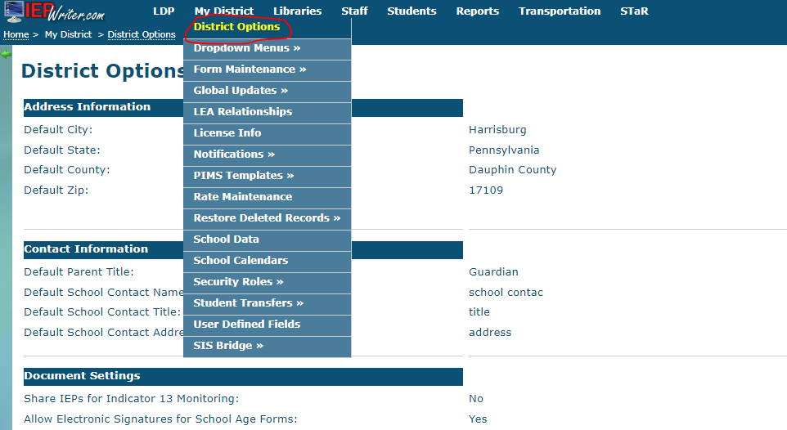
Step 2: On the District Options page click the edit button at the bottom of the screen.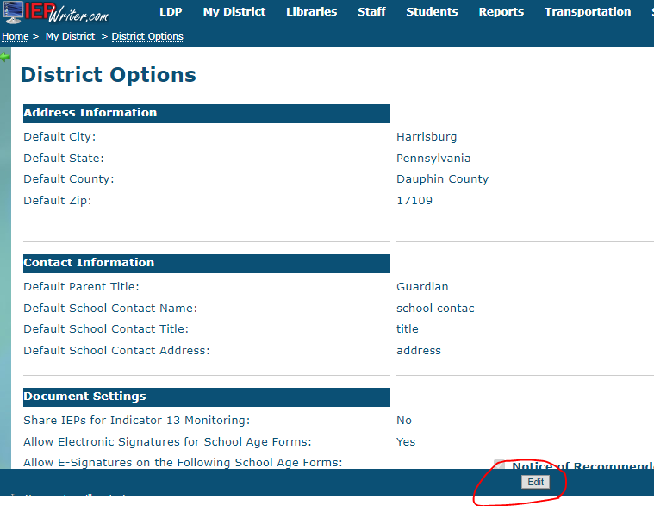
Step 3: On the edit screen for the District Options page check the box for “ Share IEPs for Indicator 13 Monitoring”
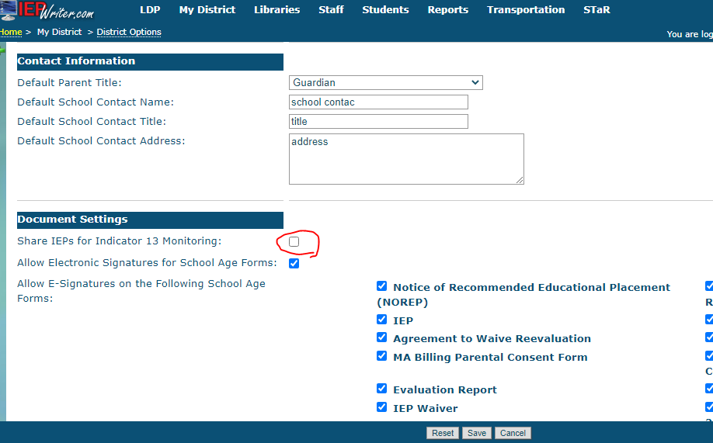
Step 4: On the edit screen for the District Options page click the “Save” button at the bottom of the page.
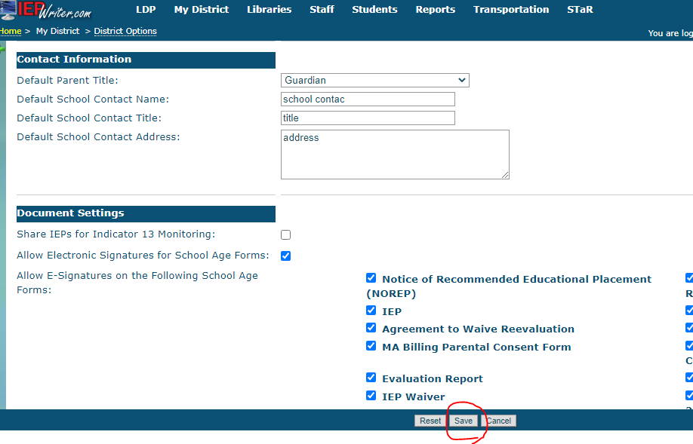

Step 5: On the District Options page click the button labeled “Complete Pre Review”.
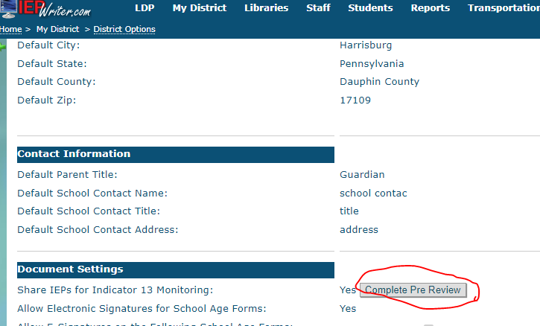
Once the Complete Pre Review button has been clicked the Pre Review is completed. Please come back at a later date to complete the Post Review.
To complete the Post Review repeat Step 5 clicking the button labeled “Complete Post Review”

