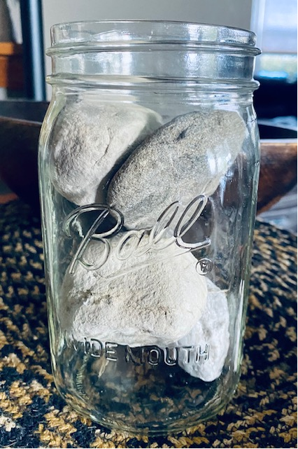
Chasing 100 -
Coaching for Secondary
Transition Change
2021-2022

September 13, 2021
9:00 AM – 11:30 AM
During this session, intermediate unit secondary transition consultants will develop and enhance their skill sets to support Local Education Agencies (LEAs) establish and maintain internal systems of support for secondary transition. Emphasis will be placed on connections to The Individuals with Disabilities Education Act (IDEA) compliance and Pennsylvania’s State Performance Plan Indicators as the foundation for strong systems.

Let’s get started with our first session of the new year:
9:00 AM – 11:30 AM - All Transition TaC
- Review and discuss Impact Coaching for Secondary Transition
- Demonstrate how IEP compliance supports better outcomes
- Examine and construct Instructional Playbook Tools
- Plan for supporting LEAs in secondary transition compliance
1:00 PM – 3:00 PM - New Transition TaC only
- Explore Transition Discoveries online module series
- Expand knowledge of the use and application of Action Research
- Apply concepts from evidence-based practices to improve transition programming

TARGET AUDIENCE
Intermediate Unit Secondary Transition Consultants

REGISTRATION

All Transition TaC – Registration Link
New Transition TaC Only – Registration Link

After registering you will receive a confirmation email containing information about joining the Webinar, including the Zoom link.

CONTACT INFORMATION

For questions regarding registration, contact:
PaTTAN Pittsburgh – Paula Quinn, pquinn@pattanpgh.net

For questions regarding content, contact:
PaTTAN Pittsburgh – Hillary Mangis, hmangis@pattanpgh.net
PaTTAN East – Jacki Lyster, jlyster@pattan.net
Continuing Education Credits: Act 48
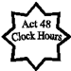
Individuals attending this virtual event must login individually, on time, using a computer or iPad, stay the duration of the event, and complete an attendance/evaluation survey by the designated deadline in order to be eligible to receive Act 48 Professional Education clock hours. This training is offered for 2 Act 48 clock hours.

