Dear (school name) Parent, OR Dear (Mr./Mrs./Ms. _______________),

Don’t miss your chance to make your voice heard!
We value your thoughts on how we can work together to improve education for our children. Your family, like others with a child receiving special education services, has a unique opportunity to help shape how schools involve families in their children’s learning. Your opinions matter and your input can make a real difference!
Why participate?
- Our school is part of The State Performance Plan Indicator 8 survey to learn how schools support family involvement in education.
- In just five minutes, you can answer five questions and share your opinion on your role in the special education process.
- Keep an eye out for a postcard with instructions on completing your personal, anonymous survey. Not all families from our school will get a survey.
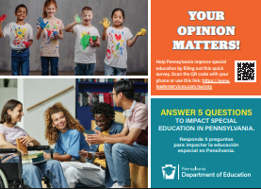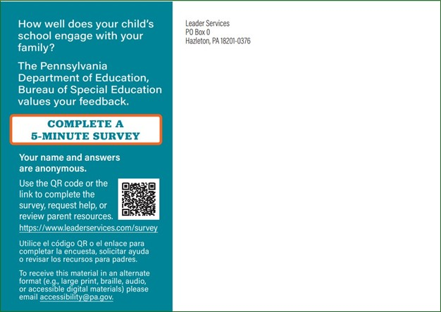
- If you receive a postcard – this is YOUR chance to make a difference! You can respond easily by scanning the QR code or using the provided URL and access code.
  - Need help? You can request assistance, a paper survey, or a different language version right on the site.
  - No internet? No problem! Call ConsultLine at 1-800-879-2301, and they’ll mail you a survey.
Every response counts! Your answers are confidential – our school won’t know who participated, but your input will help shape special education services across Pennsylvania. Join the thousands of families who have already shared their voices! Don’t miss your chance to make your voice heard. Your feedback matters!

Sincerely,

