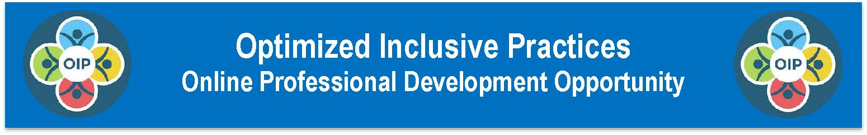
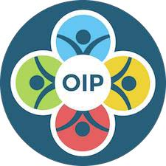

The Optimized Inclusive Practices (OIP) Professional Development Series includes nine online modules designed to provide an overview of the big ideas, concepts and competencies related to optimized inclusive practices for all students, including those with low incidence and significant cognitive disabilities. The OIP Framework guides school personnel to reflect on current data, systems and practices in their districts, schools and classrooms while charting a path towards optimized outcomes for all students.

Although the OIP Framework focuses on students with low incidence and significant cognitive disabilities, it has applicability for considering optimized inclusive practices for all learners.

Audience: District and School leaders, IU TaC who will be OIP Assessment Facilitators

Module 9: OIP Assessment Facilitator Overview
- Required
This module is REQUIRED for facilitators who will be using the OIP Assessment Tools to support a team in examining the current status of a program, school, or district in relation to Optimized Inclusive Practices.

- The OIP Assessment Process
The OIP Framework guides school personnel to reflect on current data, systems, and practices in their districts, schools and classrooms while charting a path towards optimized outcomes for all students with a special focus on those with low incidence or significant cognitive disabilities.

- The OIP Assessment Facilitator
The OIP Assessment Process is designed to be facilitated by a trained educational consultant or leader who is familiar with the OIP Framework and who is able to lead a team in discussing and reviewing evidence, determining priorities, and developing and implementing action plans.

- The OIP Assessment Tools
The OIP Assessment Tools are designed to support a team of district and school leaders, educators, family members, and possibly students to examine inclusive practices in their school/district in topic areas aligned with the Big Ideas, Concepts and Competencies described in the OIP Framework. OIP Module 9 provides an overview of the OIP Assessment Process. Tools, forms and resources needed to effectively facilitate this process with a team are provided within this module.

- Prerequisite Training
Prior familiarity with the OIP Framework is essential to successful implementation of the OIP Assessment Process. Completion of OIP Module 1: Overview of the OIP Framework is required before beginning OIP Module 9. It is strongly recommended that facilitators complete all of the OIP PD Modules before facilitating the OIP Assessment Process with a team.

Goals and Objectives for OIP Module 9:

- Identify the relationship between the OIP Framework and the OIP Assessment Tools

- Describe the five-step OIP Assessment Process and the OIP Facilitator role in that process

- Use the OIP Assessment Tools to lead teams in discussions and ratings of current program status related to Optimized Inclusive Practices

- Use a variety of facilitation, problem-solving, brainstorming strategies and tools to effectively facilitate team discussions

- Use the OIP Action Planning Process to support teams in developing effective action plans related to Optimized Inclusive Practices

- Access and use the OIP Assessment Tools and resources for fidelity of data collection, team orientation, guidance and implementation of the OIP Assessment Process and Action Plan.

Registration Information:
Participants must register for each module through encour.se. A link to each course and directions for registration are available on the PaTTAN Optimized Inclusive Practices PD Series webpage at: http://tinyurl.com/q7v4tjq

If you are already registered with encour.se, you may log in to your account to enroll in the module. If you have not registered, you may do so by clicking on the Register link from the Login page at: http://pattan.encour.se/login/pittsburgh/

Modules are available online and may be completed independently. Modules 1-5, 7-8 should take approximately 2-3 hours to complete. Module 6 and 9 may require more time due to the breadth of topics and resources. Included.

Act 48 credits may be available through your employer. Participants are encouraged to discuss options for Act 48 credits with their employer BEFORE completing the OIP PD Modules.

For further information please visit PaTTAN’s Webpage for Optimized Inclusive Practices at: http://tinyurl.com/o7h86qm

For questions regarding content, contact:
Christine Moon via email at cmoon@pattan.net

For assistance with registration, contact:
Chris Glock via email at cglock@pattan.net
.

